
Online Grading System

User guide

Table of Contents
1. Administrator 1
2. Instructor 6
3. Student 16

Administrator
1.1 Default Administrator Account
Username: admin
Password: admin

1.2 Log In
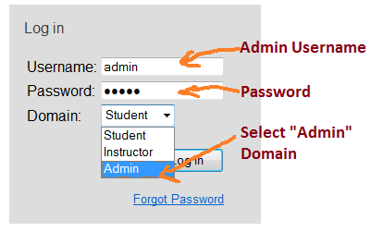
An administrator can also choose to log in as user or instructor by select the respective domain in the drop down menu.
1.3 Add/Remove Course
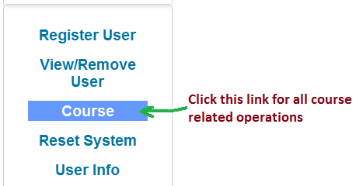
Click on the "Course" link in the left panel to manipulate courses. All the registered courses will be displayed in this page.
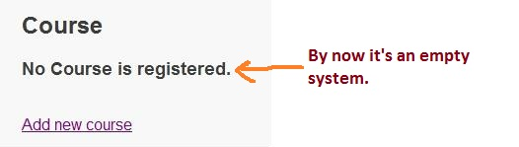

1.3.1 Add Course
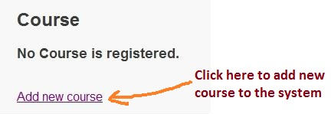
Click on "Add New Course" link in the left panel and fill in course code and course name in the form. After submission, course page will be updated.
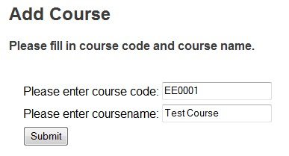
The updated course details is shown as below.
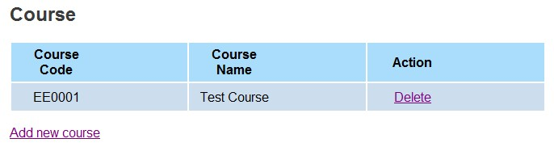
To add more courses, click on "Add new course" again, and repeat the steps above.
1.3.2 Delete Course
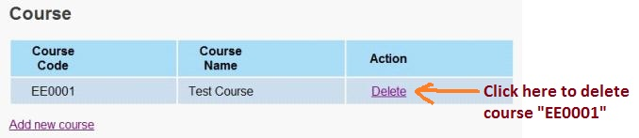
Go to the course page and find the table displaying all the registered courses. Each course can be deleted by clicking on the "Delete" link displayed in the last column.
1.4 Register/Remove User
1.4.1 Register User
To register new users to the system, administrator should prepare a text file containing usernames with file extension .txt. In the text file, one username should occupy one row. Only alphabetic characters and digits are allowed to appear in the username. In this system, the usernames are identical to NTU edventure username.
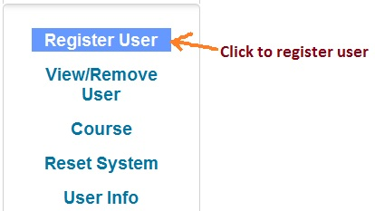
Click on "Register User" link in the left panel. First, the administrator needs to select a privilege for new users. Then, administrator needs to specify enrolled course for new users or instructors. At last, administrator upload the text file prepared just now complete the registration process.
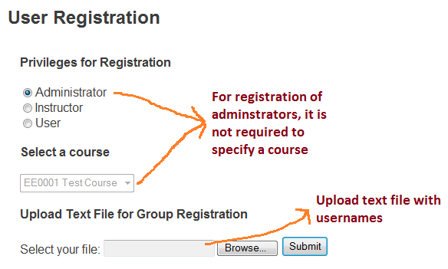

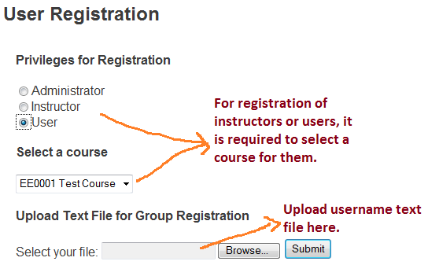

The system will show how many users are registered successfully, and highlighted those failed usernames. Registration failure for a specific username may be caused by: 1) there exists an administrator account with the target username already; 2) the target username has been registered and enrolled in the target course already. The sample registration message is shown below.
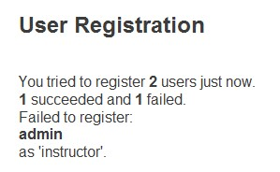
The default password for each newly registered users is identical to his username.
The username should follow NTU edventure style.
1.4.2 View/Remove User
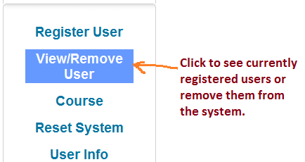
Click on "View/Remove User" link in the left panel to see the list of current registered users. Instructors and users are separated by their enrolled courses.
To delete users, check the all the check boxes in front of usernames to be removed, and click de-register. Administrator cannot de-register himself.
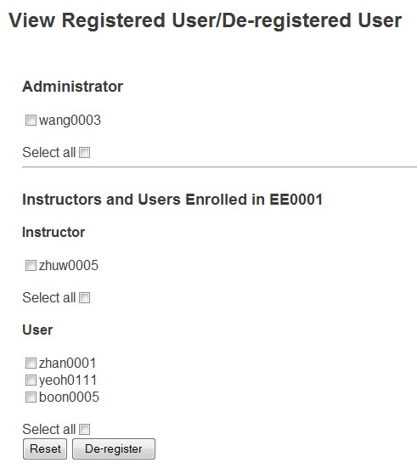
1.5 Reset System (Warning: Highly Dangerous)
Click on "Reset System" link in the left panel to remove all the users who are registered in the system and their old submissions. All the course details, instructors, administrators, and problems will not be removed.
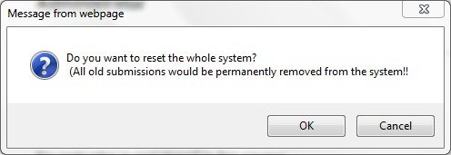

Instructor
2.1 Log in
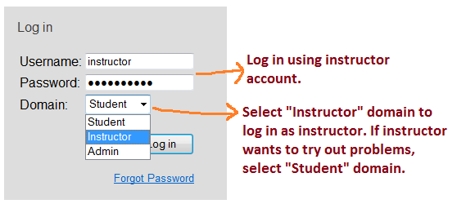
Use the instructor account registered by administrator to log in. By default, the password is the same with instructor username.
2.2 Problem/Test Case
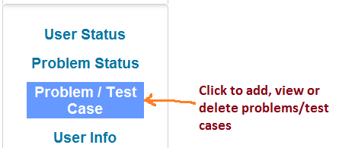
All the problem/test case related stuffs can be found via clicking on "Problem/Test Case" link in the left panel.

2.2.1 Add Problems
Click on the "Add new problems" link to start add problems.
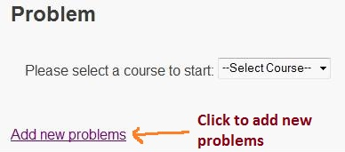
Instructor needs to select a course, because he may enrolled in multiple courses and the system requires him to specify add problems for which course. Instructor also needs to prepare a problem file, in XML format as provided in the "Sample XML File" link.
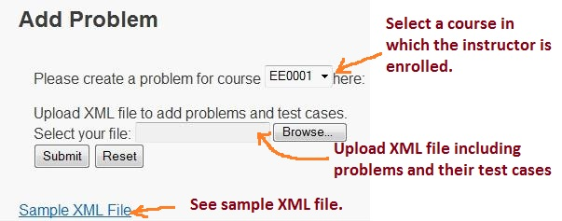
The system will reject a problem when:
- Tutorial number is not specified in XML file;
- Problem name, problem language, or brief description field is missing;
- There exists a problem with the same problem name in the target course.
The system will reject a test case for the problem when test output field is missing.

2.2.2 View/Edit Problem Details
Click on the "Problem / Test Case" in the left panel. First, select a course from the drop down menu.
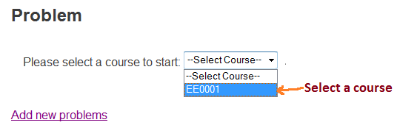
Second, select a tutorial from the drop down menu.

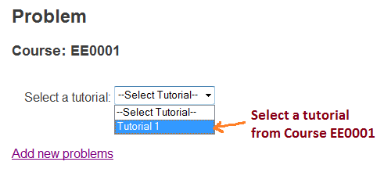
Then, all the problems in the tutorial of target course is displayed in a table.
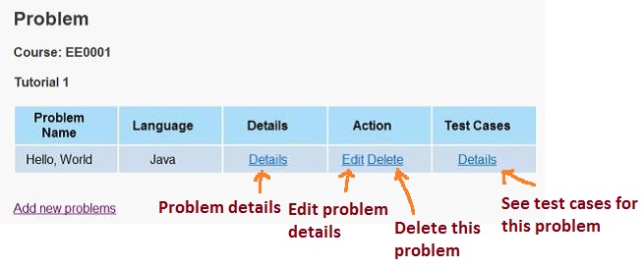
Instructor can see the problem details by clicking the link "Details" in the Details column after the target problem name. The problem details can be edited or deleted by clicking the link "Edit" or "Delete" in the Action column respectively.
The test cases associated with the problem can be found by clicking the link "Details" in the Test Cases column. Then, test cases for that problem are displayed in a table. Each test case can be edited or deleted. Instructor can add more test cases as well.
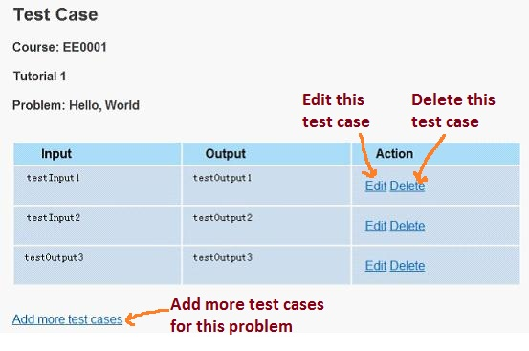
Test case editing is shown as follows.
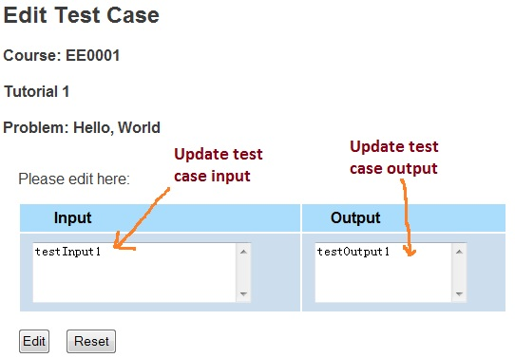
Adding more test cases is shown as below.
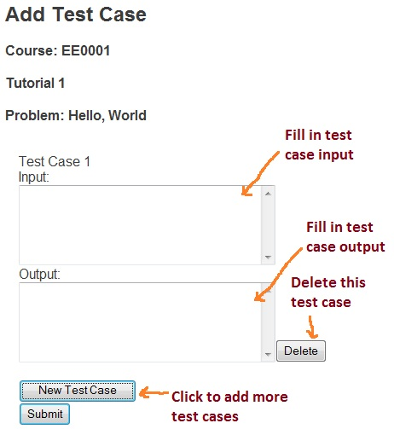

2.3 User Status
Click on "User Status" link on the left panel to start viewing user status.
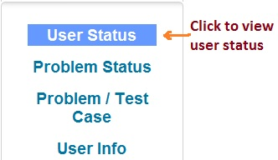
Select a target course from drop down menu.
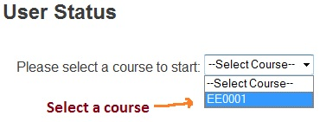
Then, there will display general status of all the students enrolled in that course.
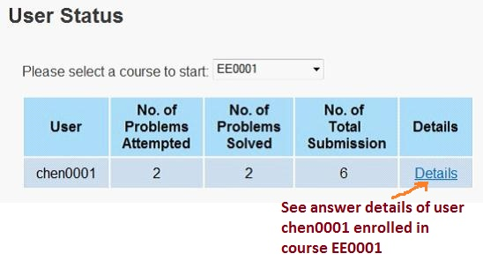
Click on the "Details" link, and it will display status of each problem which the student has attempted.
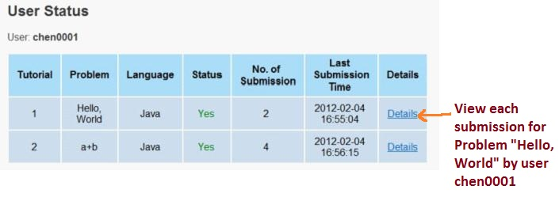
Click on the "Details" link. It will display user status of each submission for the problem.
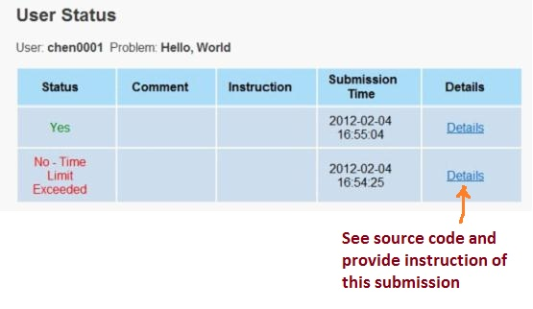
Click on the "Details" link. It will display source code of each submission. Instructor can provide instruction to the specific submission.
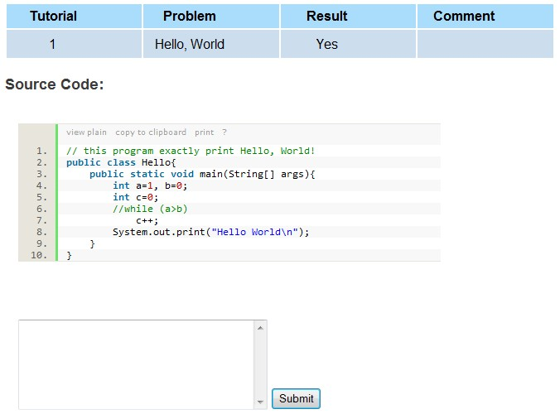

2.4 Problem Status

Click on "Problem Status" link on the left panel to start viewing problem status.
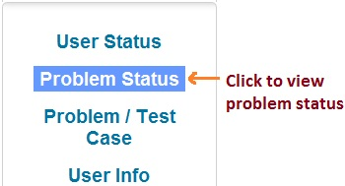
Select a target course from the drop down menu.
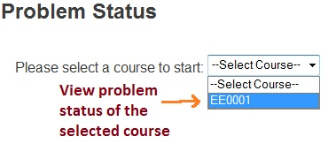
Then, there will display general status of all the problems in this course.
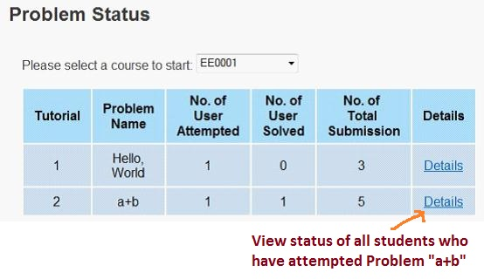
Click on "Details" link. It will display all students who attempted the target problem, and their general status.
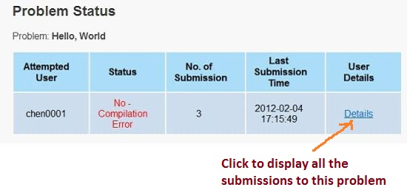
Click on "Details" link. It will display user status of each submission for the problem.
Click on "Details" link to view source code and provide instruction for each submission.

Student
3.1 Log in
To login, type in the Username and Password provided, and choose domain as ‘Student’.
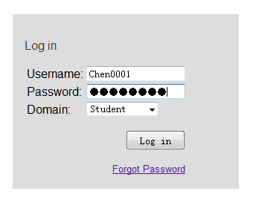
If you forgot the password, you can reset your password by click the hyperlink ‘Forgot Password’, and enter your NTU network account. After clicking submit, a system-generated email with password in would be sent to your school mailbox.
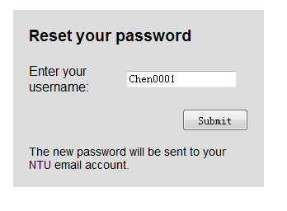
3.2 Change Password
After you login, the first thing to do is to change your password, for security concern. To change password, click the ‘Change Password’ on the right.
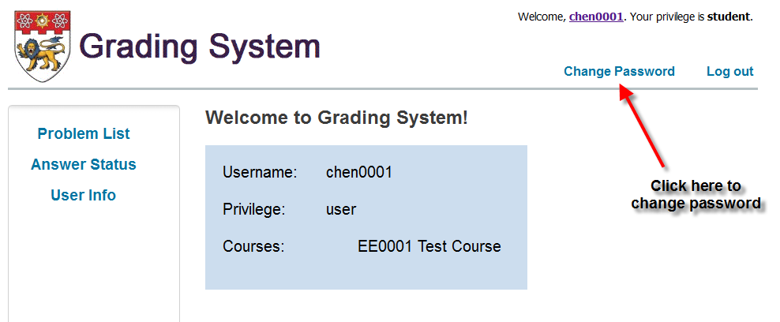
In the next shown page, enter your old password and new password.

3.3 Answer problem online
To answer problems online, first go to ‘Problem List’ page (the first page after you login). You can go to this page by click ‘Problem List’ on the left side panel.
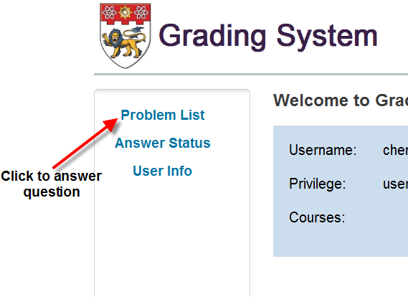
To answer problems online, first select your tutorial.
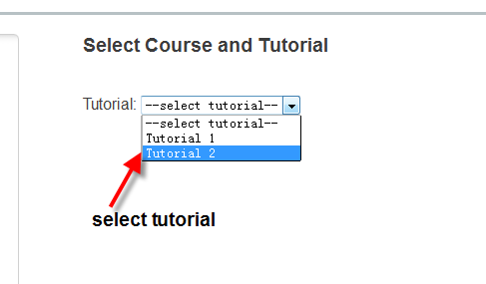

In the page shown after you select your tutorial, do as shown in the follow figure.
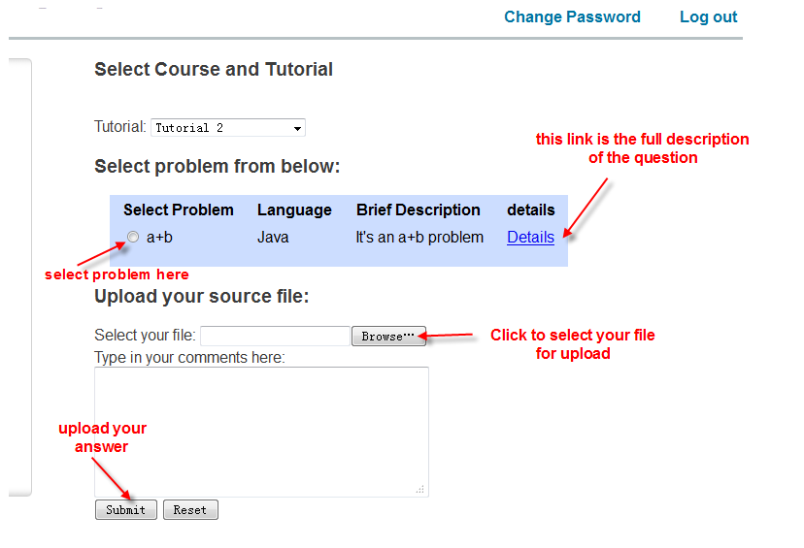
After clicking Browse, select the target source file.
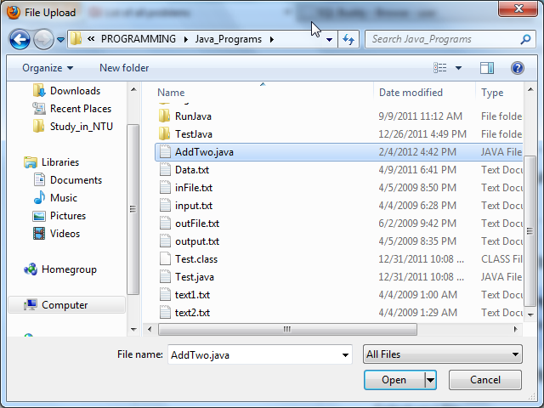
Once the file is selected, click submit to send your answer to the online judge. The running result for your problem would be shown.
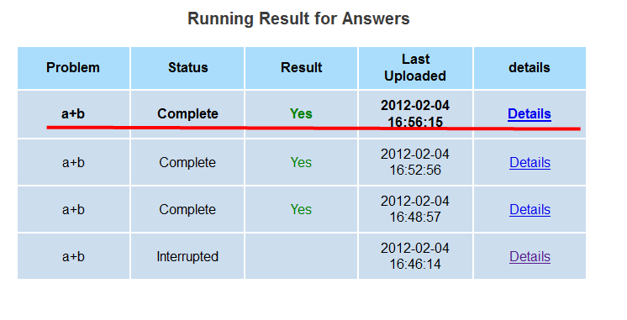
If the status displayed is not ‘complete’, you can reload this page by press F5 to view the results. A green ‘Yes’ in the Result column means your solution is successful.
If you have attempted multiple problems, you can view the result for your attempts in Answer Status page.
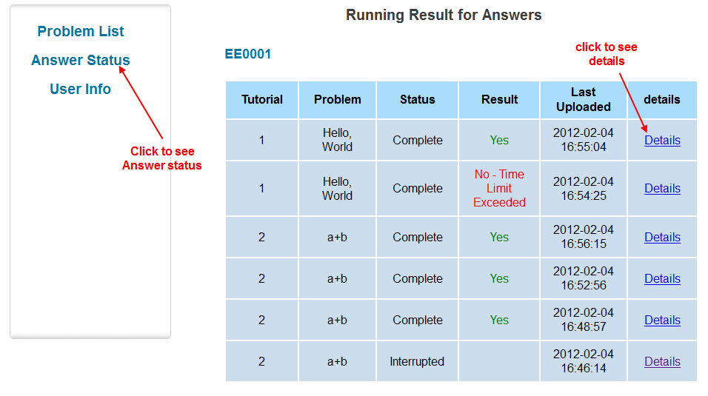
To view your source code and comments given by instructor, click the Details link on the right. A sample detail of the answer is shown below.
